Lower your cholesterol with the "Eat for Life” Whole Food Plant Based Plan
UNLIMITED:
*Eat as much as you want:
Raw vegetables (goal 1 lb.daily). Ex: Romaine, Kale, arugula, broccoli, cauliflower, brussel sprouts, spinach, etc.
*Cooked or raw green and non-green nutrient-rich vegetables (goal: 1 lb daily; EX: eggplant, mushrooms, peppers, onions, tomatoes, carrots, cauliflower).
*Beans, legumes, bean sprouts, or tofu (goal:1 cup daily).
*Fresh fruits (4 servings daily)
LIMITED:
*Cooked starchy vegetables and whole grains:

Butternut and acorn squash, corn, white potatoes, rice, sweet potatoes, bread, cereal (not more than one serving or 1 cup per day).

*Raw nuts and seeds (1 oz. max per day). *Avocado (2 oz. max per day).
***see recipes and other Whole Food Plant Based resources at:
www.stateofwell-being.com

*Dried fruit (2 tablespoons max per day). *Ground flaxseeds (1 tablespoon max per day).
OFF LIMITS:
Dairy products, animal products, processed foods, sugar, between-meal snacks, fruit juice & oils.
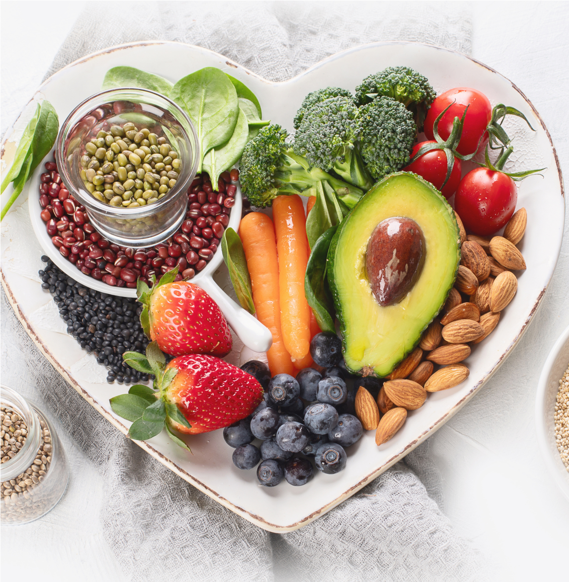
State of Well-being
with Carlisa Krenek

Ref: Joel Fuhrman, M.D. / Book: Eat for Life

